Experiment#15

**OBJECT: To become familiar with Objects and Classes in Object-Oriented Programming**

**Objects & classes**

An object has the same relationship to a class that a variable has to a data type. An object is said to be an instance of the class & a class contains data items & functions.

**Declaring a Class**

Any class is declared by the following keyword:

class class_name{

};

The parentheses contain data & functions.

**Constructors**

A constructor is a member function that is executed automatically whenever an object is created. A constructor should have the same name as the class.

**Destructors**

Destructor is a function which is mainly used to washout the memory covered by the constructor function after use.

**Overloaded Constructors**

Like any other function a constructor can also be overloaded with several functions that have the same name but different types of numbers of parameters. In fact, in the cases where we declare a class & we do not specify any constructor the compiler automatically assumes 2 overloaded constructors:

**Empty Constructor**

It is a constructor with no parameters defined as nop (empty block of instructions). It does nothing.

**Copy Constructor**

It is a constructor with only 1 parameter of its same type that assigns to every non-static class member variable of the object a copy of the past objects.

***// Program 1***

# include <iostream>

class crectangle{

int width,height;

public:

crectangle();

crectangle(int,int);

int area (void) {return (width*height);}};

crectangle::crectangle(int a,int b)

{Width=a;Height=b;}

void main()

{crectangle rect(3,4);

crectangle rectb;

cout <<”rect area:”<<rect.area()<<endl;

cout <<”rectb area:”<<rectb.area()<<endl;

getche();}

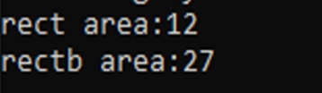

***// Program 2***

# include <iostream>

class circle{

float rad;

public :

circle(float);

float area(void) {return (3.14*rad*rad);}

float circum(void) {return (2*3.14*rad);}};

circle :: circle(float r)

{rad=r;}

void main()

{circle cir(4.5);

cout <<"\n area of cirlce "<<cir.area();

cout <<"\n cirmcumference of circle "<<cir.circum();

getche();}

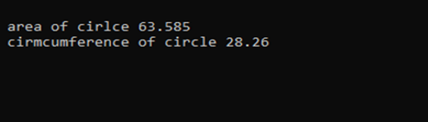

**Lab Tasks:**

QNo:01 Display outputs of above programs.

QNo:02 Develop a code that creates a class Marks with three members to store three marks

write three member functions in() to input marks, sum() to calculate and return the sum

and avg() to calculate and return the average marks.

**QUESTION NUMBER : 01:**

Display outputs of above programs.

**ANSWER:**

YOU can find your answer in above programs .

**QUESTION NUMBER : 02:**

Develop a code that creates a class Marks with three members to store three marks

write three member functions in() to input marks, sum() to calculate and return the sum

and avg() to calculate and return the average marks.

**PROGRAM:**

#include<iostream>

using namespace std;

class marks{

private:

int mark1;

int mark2;

int mark3;

public:

void set_marks(){

cout<<"Enter mark 1: ";

cin>>mark1;

cout<<"Enter mark 2: ";

cin>>mark2;

cout<<"Enter mark 3: ";

cin>>mark3;

}

int sum(){

return mark1+mark2+mark3;

}

float avg(){

return (float)( sum())/3.0;

}

};

int main() {

int num;

marks mark;

mark.set_marks();

cout<<"Sum: "<<mark.sum()<<"\n";

cout<<"Avg: "<<mark.avg()<<"\n";

cin>>num;

return 0;

}

**OUTPUT:**

